=



**Project Report On**

**“Car Price Prediction”**



**Submitted by:**

**Trupti Badole**

**ACKNOWLEDGMENT**

I would like to express my sincere thanks of gratitude to my SME as well as “Flip Robo Technologies” team for letting me work on “Flight Price Prediction” project also huge thanks to my academic team “DataTrained”. Their suggestions and directions have helped me in the completion of this project successfully. This project also helped me in doing lots of research wherein I came to know about so many new things.

Finally, I would like to thank my family and friends who have helped me with their valuable suggestions and guidance and have been very helpful in various stages of project completion.

**References:**

1. https://www.google.com/

2. <https://www.youtube.com/>

3. <https://github.com/>

4. https://www.kaggle.com/

5. <https://medium.com/>

6. <https://towardsdatascience.com/>

7. https://www.analyticsvidhya.com/

**TABLE OF CONTENTS:**

1. **Introduction**
   1. Business Problem Framing
   2. Conceptual Background of the Domain Problem
   3. Review of Literature
   4. Motivation for the Problem Undertaken
2. **Analytical Problem Framing**
   1. Mathematical/ Analytical Modelling of the Problem
   2. Data Sources and their formats
   3. Data Pre-processing Done
   4. Data Inputs- Logic- Output Relationships
   5. Hardware & Software Requirements & Tools Used
3. **Model/s Development and Evaluation**
   1. Identification of possible Problem-solving approaches (Methods
   2. Visualizations
   3. Testing of Identified Approaches (Algorithms)
   4. Run and Evaluate Selected Models
   5. Key Metrics for success in solving problem under consideration
   6. Interpretation of the Results
4. **Conclusion**
   1. Key Findings and Conclusions of the Study
   2. Learning Outcomes of the Study in respect of Data Science
   3. Limitations of this work and Scope for Future Work
5. **INTRODUCTION**

Predicting the price of used cars is an important and interesting problem. Predicting the resale value of a car is not a simple task. It is common knowledge that the value of used cars depends on a number of factors. The most important ones are usually the age of the car, its make (model), the origin of the car (the original location of the manufacturer), its mileage (the number of kilometers it has run) and its horsepower (amount of power that an engine produces). Due to rising fuel prices, fuel economy is also of prime importance. Unfortunately, in practice, most people do not know exactly how much fuel their car consumes for each km driven. Other factors such as the type of fuel it uses, the interior style, the braking system, acceleration, engine displacement, the volume of its cylinders (measured in cc), its size, number of doors, paint colour, cargo_volume, consumer reviews, prestigious awards won by the car manufacturer, its physical state, whether it is a sports car, whether it has cruise control, whether it is automatic or manual transmission, whether it belonged to an individual or a company and other options such as air conditioner, sound system, power steering, cosmic wheels, GPS navigator all may influence the price as well. Some special factors which buyers attach importance is the local of previous owners, whether the car had been involved in serious accidents. The look and feel of the car certainly contribute a lot to the price. As we can see, the price depends on a large number of factors. Unfortunately, information about all these factors is not always available and the buyer must make the decision to purchase at a certain price based on few factors only. In this work, we have considered only a small subset of the factors which are more important.

**1.1 Business Problem Framing**

With the covid 19 impact in the market, we have seen lot of changes in the car market. Now some cars are in demand hence making them costly and some are not in demand hence cheaper. One of our clients works with small traders, who sell used cars. With the change in market due to covid 19 impact, our client is facing problems with their previous car price valuation machine learning models. So, they are looking for new machine learning models from new data. We have to make car price valuation model.

Nowadays, the number of people using flights has increased significantly. It is difficult for airlines to maintain prices since prices change dynamically due to different conditions. That’s why we will try to use machine learning models to solve this problem. This can help airlines by predicting what prices they can maintain. It can also help customers to predict future flight prices and plan their journey accordingly.

**Business goal:** The main aim of this project is to predict the price of used car based on various features. Machine Learning is a field of technology developing with immense abilities and applications in automating tasks. So, we will deploy an ML model for car selling price prediction and analysis. This model will provide the approximate selling price for the car based on different features like fuel type, transmission, price, cargo volume, running in kms, engine displacement, milage etc. and this model will help the client to understand the price of used cars.

**1.2 Conceptual Background of the Domain Problem**

Car Price Prediction is really an interesting machine learning problem as there are many factors that influence the price of a car in the second-hand market. In many developed countries, it is common to lease a car rather than buying it outright. A lease is a binding contract between a buyer and a seller (or a third party – usually a bank, insurance firm or other financial institutions) in which the buyer must pay fixed instalments for a pre-defined number of months/years to the seller/financer. After the lease period is over, the buyer has the possibility to buy the car at its residual value, i.e., its expected resale value. Thus, it is of commercial interest to seller/financers to be able to predict the salvage value (residual value) of cars with accuracy. If the residual value is underestimated by the seller/financer at the beginning, the instalments will be higher for the clients who will certainly then opt for another seller/financer. If the residual value is over-estimated, the instalments will be lower for the clients but then the seller/financer may have much difficulty at selling these high-priced used cars at this over-estimated residual value. Thus, we can see that estimating the price of used cars is of very high commercial importance as well. Here we are trying to help the client with small traders, who sell used cars to understand the price of the used cars by deploying machine learning models. These models would help the client/sellers to understand the used car market and accordingly they would be able to sell the used car in the market.

**1.3 Review of Literature**

Literature review covers relevant literature with the aim of gaining insight into the factors that are important to predict the price of used cars in the market. In this study, we discuss various applications and methods which inspired us to build our supervised ML techniques to predict the price of used cars in different locations. We did a background survey regarding the basic ideas of our project and used those ideas for the collection of data information by doing web scraping from www.cardekho.com website which is a web platform where seller can sell their used car. This project is more about data exploration, feature engineering and pre-processing that can be done on this data. Since we scrape huge amount of data that includes more car related features, we can do better data exploration and derive some interesting features using the available columns. Different techniques like ensemble techniques, k-nearest neighbours, and decision trees have been used to make the predictions. The goal of this project is to build an application which can predict the car prices with the help of other features. In the long term, this would allow people to better explain and reviewing their purchase with each other in this increasing digital world.

**1.4 Motivation for the Problem Undertaken**

Deciding whether a used car is worth the posted price when you see listings online can be difficult. Several factors including mileage, engine displacement, running, make, model, year, etc. can influence the actual worth of a car. From the perspective of a seller, it is also a dilemma to price a used car appropriately. So, the main aim is to use machine learning algorithms to develop models for predicting used car prices.

• To build a supervised machine learning model for forecasting value of a used vehicle based on multiple attributes.

• The system that is being built must be feature based i.e., feature wise prediction must be possible.

• Providing graphical comparisons to provide a better view.

**2. ANALYTICAL PROBLEM FRAMING**

**2.1 Mathematical/ Analytical Modelling of the Problem:**

**We need to develop an efficient and effective Machine Learning model which predicts the price of a used cars. So, “Car_Price” is our target variable which is continuous in nature. Clearly it is a Regression problem where we need to use regression algorithms to predict the results.**

**This project is done on two phases:**

**Data Collection Phase:** **I** have done web scraping to collect the data of used cars from the well-known website www.cardekho.com where I found more features of cars compared to other websites and I fetched the data for different locations and models. As per the requirement of our client we need to build the model to predict the prices of these used cars.

* **Data Analysis:** After cleaning the data I have done some analysis on the data by using different types of visualizations.
* **Model Building Phase:** After collecting the data, I built a machine learning model. Before model building, have done all data pre-processing steps. The complete life cycle of data science that I have used in this project are as follows:
* Data Cleaning
* Exploratory Data Analysis
* Data Pre-processing
* Model Building
* Model Evaluation
* Selecting the best model

**2.2 Data Sources and their formats**

We have collected the dataset from the website www.cardekho.com which is a web platform where seller can sell their used car. The data is scrapped using Web scraping technique and the framework used is Selenium. We scrapped nearly 10748 of the data and fetched the data for different locations and collected the information of different features of the car and saved the collected data in excel format. The dimension of the dataset is 10748 rows and 20 columns including target variable “Car_Price”. The particular dataset contains both categorical and numerical data type. The data description is as follows:

|  |  |
| --- | --- |
| **Variables** | **Definition** |
| Car_Name | Name of the cars with manufacturing year |
| Fuel_type | Type of fuel used for car engine |
| Running_in_kms | Car running in kms till the date |
| Engine_disp | Engine displacement/engine CC |
| Gear_transmission | Type of gear transmission used in car |
| Milage_in_km/ltr | Overall milage of car in Km/ltr |
| Seating_cap | Number of seats available in the car |
| color | Color of the car |
| Color of the car | Maximum power of engine used in car in bhp |
| front_brake_type | Type of brake system used for front-side wheels |
| rear_brake_type | Type of brake system used for back-side wheels |
| cargo_volume | Total cubic feet of space in a car's cargo area |
| height | Total height of car in mm |
| width | Width of car in mm |
| length | Total length of the car in mm |
| Weight | Gross weight of the car in kg |
| Insp_score | Inspection rating out of 10 |
| top_speed | Maximum speed limit of the car in km per hours |
| City_url | Url of the page of cars from a particular city/location |
| Car_price | Price of the car |

**2.3 Data Pre-processing Done**

* Data pre-processing is the process of converting raw data into a well readable format to be used by Machine Learning model. Data pre-processing is an integral step in Machine Learning as the quality of data and the useful information that can be derived from it directly affects the ability of our model to learn; therefore, it is extremely important that we pre-process our data before feeding it into our model. I have used following pre-processing steps:
* Importing necessary libraries and loading collected dataset as a data frame.
* Used pandas to set display maximum columns and rows ensuring not to find any truncated information.
* Checked some statistical information like shape, number of unique values present, info, unique () data types etc.
* From the dataset I found some numerical features having “- “sign and string value like “null” so I replaced them with NAN values and dropped

the columns having more than 50% of “-“ sign and null values as they were of no use for prediction.

* Done feature engineering on some features as they had some irrelevant values like kms, kmpl and replaced them by empty space.
* Extracted the features Brand, Model and Manufacturing_year from the column Car_Name and created Car_age by subtracting the Manufacturing year of car from the year 2022. Replaced string values and “- “sign by empty space in some of the columns to get the numerical data.
* The target variable "Car_price" should be continuous data but due to some string values it was showing as object data type. So, I replaced those entries with appropriate values. Then split the column into two as price_a and price_b and stored numerical values in price_a column and string values in price_b column and after that multiplied those two columns to get exact car price in numerical format.
* The column City_url contained the urls of the cities, so I created a new column as Location by replacing the urls by specific city name.
* The columns "front_brake_type" and “rear_brake_type” were had some duplicate entries that is the entries belongs to same categories so, I replaced/grouped the same categories by appropriate values.
* Converted all the numerical continuous columns from object data type into float data type after cleaning the data and saved the cleaned data in excel file format.
* Checked for null values and treated them using imputation techniques like mean, median and mode methods. Checked the statistical summary of the dataset using describe () method. Separated both numerical and categorical columns for further process.
* Performed univariate, bivariate and multivariate analysis to visualize the data. Visualized each feature using seaborn and matplotlib libraries by plotting several categorical and numerical plots like pie plot, count plot, bar plot, reg plot, strip plot, line plot, violin plot, distribution plot, box plots and pair plot.
* Identified outliers using box plots and removed outliers in continuous numerical columns using Zscore and stored the data frame after removing outliers as “new_df”.
* Checked for skewness and removed skewness in numerical columns using power transformation method (yeo-johnson).
* Encoded the columns having object data type using Label Encoder method. Used Pearson’s correlation coefficient to check the correlation between label and features. With the help of heatmap and correlation bar

graph was able to understand the Feature vs Label relativity and insights on multicollinearity amongst the feature columns.

* Separated the feature and label data and feature scaling is performed using Standard Scaler method to avoid any kind of data biasness.
* Checked Variance Inflation Factor (VIF) and dropped the column “Max_power” as it was containing VIF close to 10 and got rid of multicollinearity issue.
  1. **Data Inputs- Logic- Output Relationships**

The dataset consists of label and features. The features are independent and label is dependent as the values of our independent variables changes as our label varies.

• Since we had both numerical and categorical columns, I checked the distribution of skewness using dist. plots for numerical features and checked the counts using count plots & pie plots for categorical features as a part of univariate analysis.

• To analyze the relation between features and label I have used many plotting techniques where I found numerical continuous variables having strong relation with label Car_Price with the help of reg plot.

• I have checked the correlation between the label and features using heat map and bar plot. Where I got both positive and negative correlation between the label and features.

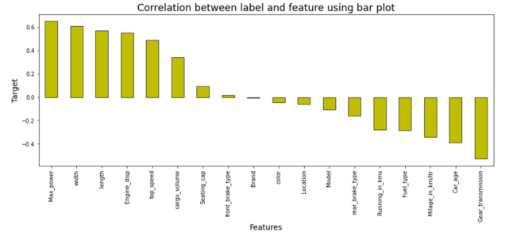

**2.5 Hardware & Software Requirements & Tools Used**

To build the machine learning projects it is important to have the following hardware and software requirements and tools.

**Hardware required:**

* Processor: core i5 or above
* RAM: 8 GB or above
* ROM/SSD: 250 GB or above

**Software required:**

* Distribution: Anaconda Navigator
* Programming language: Python
* Browser based language shell: Jupyter Notebook
* Chrome: To scrape the data

**Libraries required:**

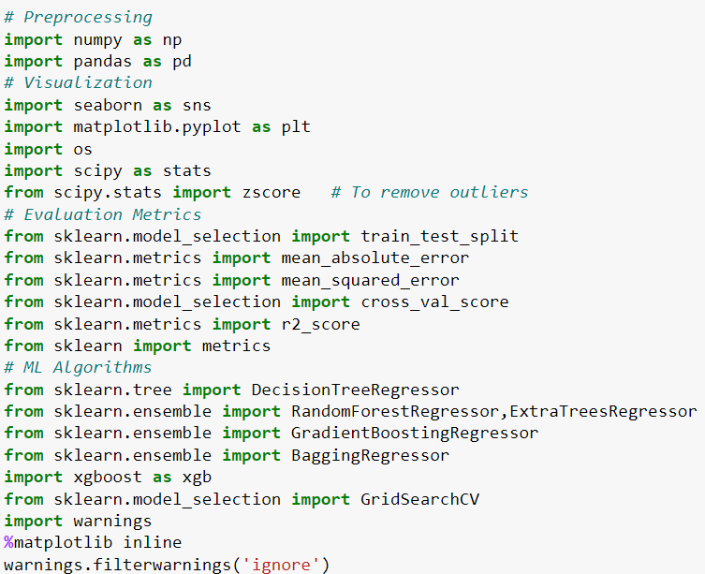

* **import numpy as np:** It is defined as a Python package used for performing the various numerical computations and processing of the multidimensional and single dimensional array elements. The calculations using Numpy arrays are faster than the normal Python array.
* **import pandas as pd:** Pandas is a Python library that is used for faster data analysis, data cleaning and data pre-processing. The data-frame term is coming from Pandas only.
* **import matplotlib.pyplot as plt:** Matplotlib and Seaborn acts as the backbone of data visualization through Python.

**Matplotlib**: It is a Python library used for plotting graphs with the help of other libraries like Numpy and Pandas. It is a powerful tool for visualizing data in Python. It is used for creating statical interferences and plotting 2D graphs of arrays.

* **import seaborn as sns: Seaborn** is also a Python library used for plotting graphs with the help of Matplotlib, Pandas, and Numpy. It is built on the roof of Matplotlib and is considered as a superset of the Matplotlib library. It helps in visualizing univariate and bivariate data.

With the above sufficient libraries, we can perform pre-processing, data cleaning and can build ML models.

**3.** **MODEL/S DEVELOPMENT AND EVALUATION**

**3.1 Identification of possible Problem-solving approaches (Methods):**

I have used both statistical and analytical approaches to solve the problem which mainly includes the pre-processing of the data also used EDA techniques and heat map to check the correlation of independent and dependent features. Treated null values using imputation methods. Removed outliers and skewness using Zscore and yeo-johnson methods respectively. Encoded data using Label Encoder. Also, before building the model, I made sure that the input data is cleaned and scaled before it was fed into the machine learning models. Checked for the best random state to be used on our Regression Machine Learning model pertaining to the feature importance details. Finally created multiple regression models along with evaluation metrics. For this particular project we need to predict price of used cars. In this dataset, Car_Price is the target variable, which means our target column is continuous in nature so this is a regression problem. I have used many regression algorithms and predicted the car price. By doing various evaluations I have selected Extreme Gradient Boosting Regressor (XGB) as best suitable algorithm to create our final model as it is giving least difference in R2 score and cross validation score among all the algorithms used. In order to get good performance and to check whether my model getting over-fitting and underfitting I have made use of the K-Fold cross validation by setting cv=5 and then hyper parameter tuning on best model. Then I saved my final model and loaded the same for predictions

**3.2 Testing of Identified Approaches (Algorithms)**

Since “Car_Price” is my target variable which is continuous in nature, from this I can conclude that it is a regression type problem hence I have used following regression algorithms. After the pre-processing and data cleaning I was left with 18 columns including target and with the help of feature importance bar graph I used these independent features for model building and prediction. The algorithms used on training the data are as follows:

1. Decision Tree Regressor
2. Random Forest Regressor
3. Extra Trees Regressor
4. Gradient Boosting Regressor
5. Extreme Gradient Boosting Regressor (XGB)
6. Bagging Regressor
7. KNeighbors Regressor (KNN)
   1. **Run and evaluate selected models**

I have used 7 regression algorithms after choosing random state amongst 1-1000 number. I have used Random Forest Regressor to find best random state and the code is as below:

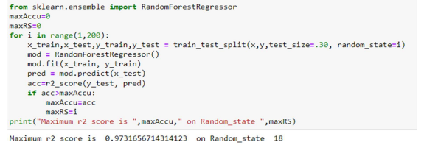

### Model Building:

### Decision Tree Regressor:

**Decision Tree Regressor** is a decision-making tool that uses a flowchart like tree structure. It observes features of an object and trains a model in the structure of a tree to predict data in the future to produce meaningful continuous output.

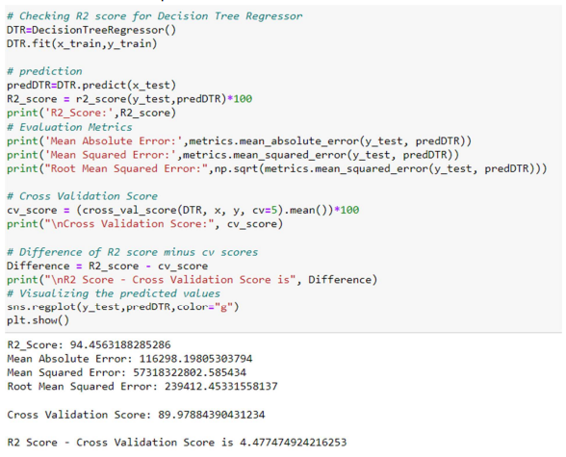

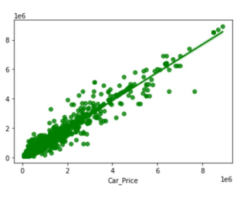

* Created Decision Tree Regressor model and checked for its evaluation metrics. The model is giving R2 score as 94.456%.
* From the graph we can observe how our model is mapping. In the graph we can observe the straight line which is our actual dataset and dots are the predictions that the model has given.

1. **Random Forest Regressor:**

**Random forest** is an ensemble technique capable of performing both regression and classification tasks with use of multiple decision trees and a technique called Bootstrap Aggregation. It improves the predictive accuracy and control over-fitting.

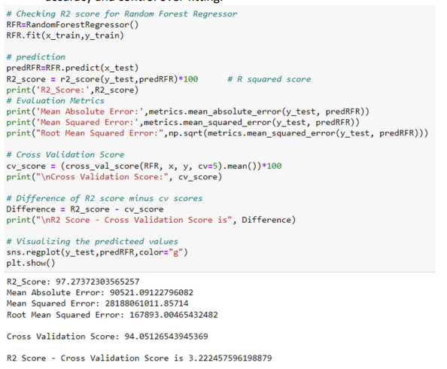

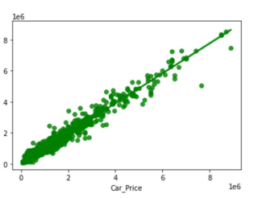

Created Random Forest Regressor model and checked for it evaluation metrics. The model is giving R2 score as 97.273%.

From the graph we can observe how our model is mapping. In the graph we can observe the straight line which is our actual dataset and dots are the predictions that our model has given.

1. **Extra Trees Regressor:**

The **Extra Trees** implements a meta estimator that fits a number of randomized decision trees (a.k.a. extra-trees) on various sub-samples of the dataset and uses averaging to improve the predictive accuracy and control over-fitting.

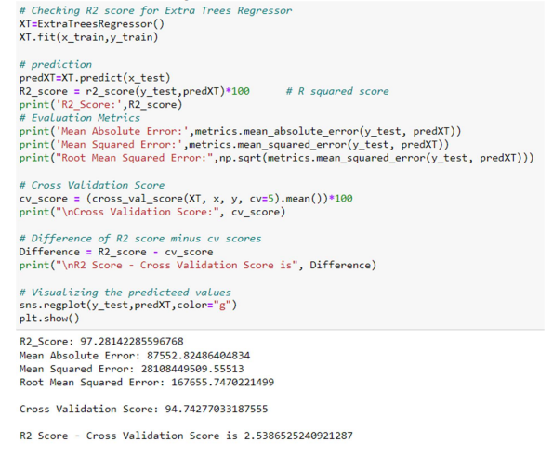

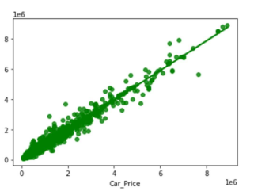

* Created Extra Trees Regressor model and checked for its evaluation metrics. The model is giving R2 score as 97.281%.
* From the graph we can observe how our model is mapping. In the graph we can observe the straight line which is our actual dataset and dots are the predictions that our model has given.

1. **Gradient Boosting Regressor:**

**Gradient Boosting Regressor** is also works for both numerical as well as categorical output variables. It produces a prediction model in the form of an ensemble of weak prediction models, typically decision trees. This model was chosen to account for non-linear relationships between the features & predicted price, by splitting the data into 100 regions.

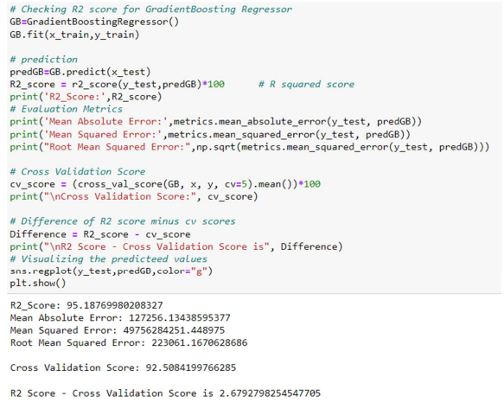

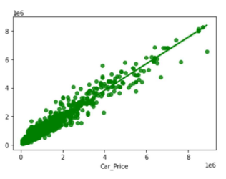

* Created Gradient Boosting Regressor model and checked for its evaluation metrics. The model is giving R2 score as 97.526%.
* From the graph we can observe how our model is mapping. In the graph we can observe the straight line which is our actual dataset and the dots are the predictions that our model has given.

1. **Extreme Gradient Boosting Regressor (XGB Regressor):**

**XGB Regressor** is a popular supervised machine learning model and it is an implementation of Gradient Boosting trees algorithm. It is best known to provide better solutions than other machine learning algorithms.

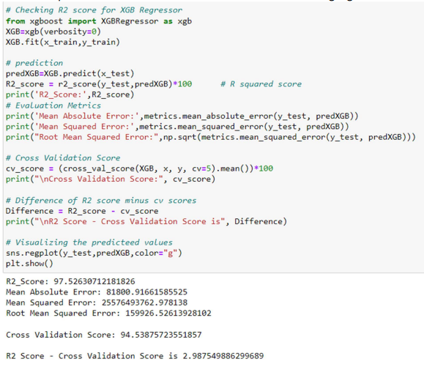

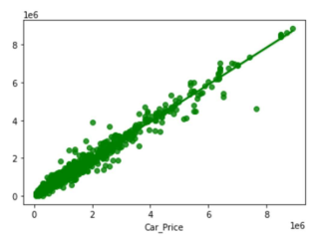

* Created XGB Regressor model and checked for its evaluation metrics. The model is giving R2 score as 96.688%.
* From the graph we can observe how our model is mapping. In the graph we can observe the straight line which is our actual dataset and the dots are the predictions that our model has given.

1. **Bagging Regressor:**

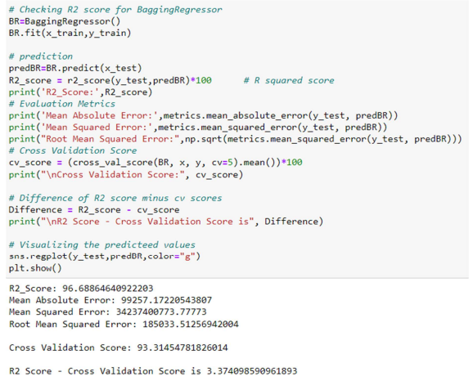**A Bagging regressor** is an ensemble meta-estimator that fits base regressors each on random subsets of the original dataset and then aggregate their individual predictions to form a final prediction.

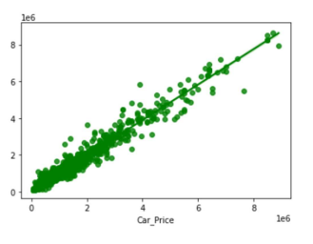

* Created Bagging Regressor model and checked for its evaluation metrics. The model is giving R2 score as 96.688%.
* From the graph we can observe how our model is mapping. In the graph we can observe the straight line which is our actual dataset and the dots are the predictions that our model has given.

1. **K Nearest Neighbors Regressor:**

The K nearest neighbors is a simple algorithm that stores all available cases and predict the numerical target based on a similarity measure and it uses ‘feature similarity’ to predict the values of any new data points. This means that the new point is assigned a value based on how closely it resembles the points in the training set.

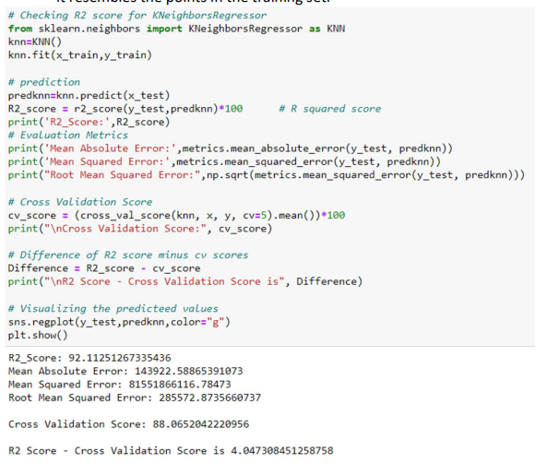

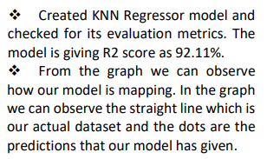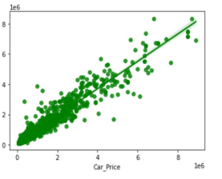

**Key Metrics for success in solving problem under consideration:**

**The key metrics used here were r2_score, cross_val_score, MAE, MSE and RMSE. We tried to find out the best parameters and also to increase our scores by using Hyperparameter Tuning and we will be using GridSearchCV method.**

**1. Cross Validation: Cross-validation helps to find out the over fitting and under fitting of the model. In the cross validation the model is made to run on different subsets of the dataset which will get multiple measures of the model. If we take 5 folds, the data will be divided into 5 pieces where each part being 20% of full dataset. While running the Cross-validation the 1st part (20%) of the 5 parts will be kept out as a holdout set for validation and everything else is used for training data. This way we will get the first estimate of the model quality of the dataset. In the similar way further iterations are made for the second 20% of the dataset is held as a holdout set and remaining 4 parts are used for training data during process. This way we will get the second estimate of the model quality of the dataset. These steps are repeated during the cross-validation process to get the remaining estimate of the model quality and their mean are taken for the final CV score.**

**2. R2 Score: It is a statistical measure that represents the goodness of fit of a regression model. The ideal value for R2 Score is 1. The closer the value of R2 Score to 1, the better is the model fitted.**

**3. Mean Squared Error (MSE): MSE of an estimator (of a procedure for estimating an unobserved quantity) measures the average of the squares of the errors — that is, the average squared difference between the estimated values and the actual value. MSE is a risk function, corresponding to the expected value of the squared error loss. RMSE is the Root Mean Squared Error.**

**4. Mean Absolute Error (MAE): MAE measures the average magnitude of the errors in a set of predictions, without considering their direction. It’s the average over the test sample of the absolute differences between prediction and actual observation where all individual differences have equal weight.**

**5. Hyperparameter Tuning: There is a list of different machine learning models. They all are different in some way or the other, but what makes them different is nothing but input parameters for the model. These input parameters are named as Hyperparameters. These hyperparameters will define the architecture of the model, and the best part about these is that you get a choice to select these for your model. You must select from a specific list of hyperparameters for a given model as it varies from model to model. We are not aware of optimal values for hyperparameters which would generate the best model output. So, what we tell the model is to explore and select the optimal model architecture automatically. This selection procedure for hyperparameter is known as Hyperparameter Tuning. We can do tuning by using GridSearchCV. GridSearchCV is a function that comes in Scikit-learn (or SK-learn) model selection package. An important point here to note is that we need to have Scikit-learn library installed on the computer. This function helps to loop through predefined hyperparameters and fit your estimator (model) on your training set. So, in the end, we can select the best parameters from the listed hyperparameters.**

**Model Selection:**

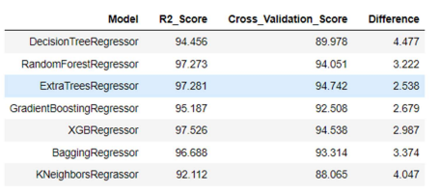

**From the difference between R2 score and Cross Validation score, it can be seen that the XGB Regressor has least difference and low evaluation metrics compared to other models. That is XGBoosting as a regression gave the best R2 score, MAE, MSE and RMSE values. So, we can conclude that XGB Regressor as our best fitting model. Let's try to increase our model score by tuning the best model using different types of hyper parameters.**

**Hyper Parameter Tuning:**

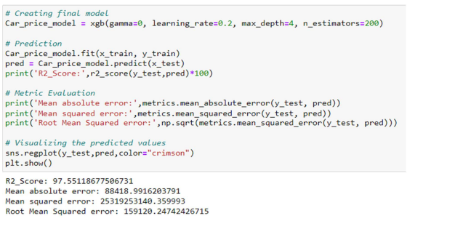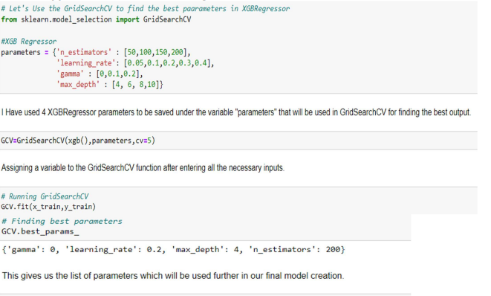

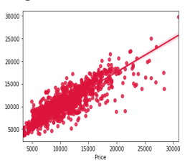

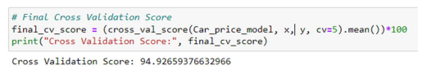

* **I have successfully incorporated the hyper parameter tuning using best parameters of XGB Regressor by using GridSearchCV and the R2 score of the model has been increased after hyperparameter tuning and received the R2 score as 97.551% and Cross Validation score as 94.9265% which is very good.**
* **From the graph we can observe how our final model is mapping. In the graph we can observe the best fit line which is our actual dataset and the dots are the predictions that our best final model has given.**

**Saving the final model and predicting the flight ticket price**

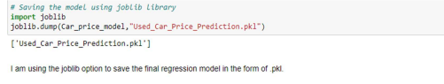

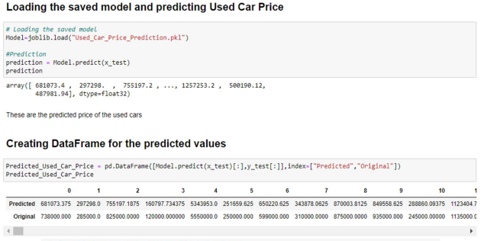

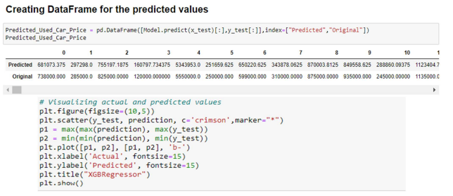

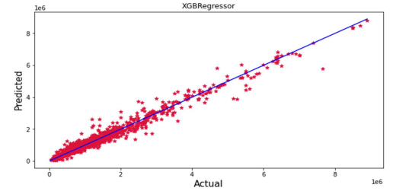

The graph shows how our final model is mapping. The plot gives the linear relation between predicted and actual price of the flight tickets. The blue line is the best fitting line which gives the actual values/data and red dots gives the predicted values/data.

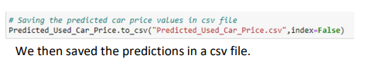

* 1. **Visualizations**

I used pandas profiling to get the over viewed visualization on the pre-processed data. Pandas is an open-source Python module with which we can do an exploratory data analysis to get detailed description of the features and it helps in visualizing and understanding the distribution of each variable. I have analysed the data using univariate, bivariate and multivariate analysis. In univariate analysis I have used distribution plot, pie plot and count plot and in bivariate analysis I have used bar plots, strip plots, box plots and boxen plots to get the relation between categorical variables and target column Price and used line plots, reg plot, box plot, bar plot, boxen plot and factor plot to understand the relation between continuous numerical variables and target variable. Apart from these plots I have used pair plot (multivariate analysis) and box plots to get the insight from the features.

**Univariate Analysis:** Univariate analysis is the simplest way to analyse data. “Uni” means oneand this means that the data has only one kind of variable. The major reason for univariate analysis is to use the data to describe. The analysis will take data, summarise it, and then find some pattern in the data. Mainly we will get the counts of the values present in the features.

**Univariate Analysis for Numerical Variables:**

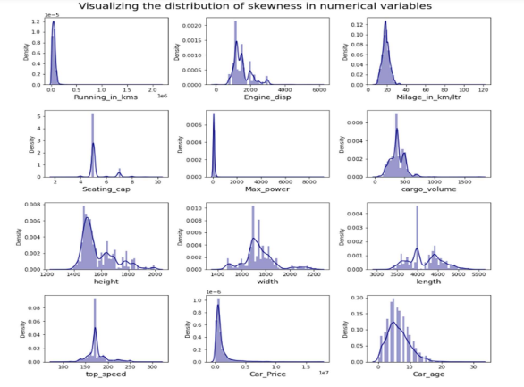

**Distribution of Skewness in Numerical Columns:**

**Observations:**Above plot shows how the data has been distributed in each of the columns.

From the distribution plots we can observe most of the columns are not normally distributed, only the columns "Milage_in_km/ltr" looks somewhat normal.

Also, we can notice the columns like "Running_in_kms", "Engine_disp", "Milage_in_km/ltr", "Seating_cap", "Max_power", "cargo_volume", "height", "width", "length", "top_speed", "Car_Price", "Car_age" etc are skewed to right as the mean value in these columns are much greater than the median (50%).

**Bivariate Analysis: Bivariate analysis** is one of the statistical analyses where two variables are observed, Bi means two variables. One variable here is dependent while the other is independent. These variables are usually denoted by X and Y. We can also analyse the data using both independent variables. Bivariate analysis is finding some kind of empirical relationship between two variables using different plotting techniques.

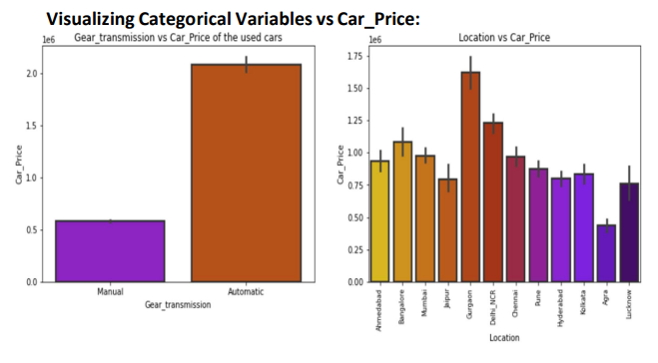

**Observations:**

Car_Price vs Gear_transmission: From the bar plot we can observe that the cars which have Automatic gear transmission system are having high price compared to the cars which have Manual gear transmission system.

Car_Price vs Location: From the second plot we came to know that the old cars from the city Gurgaon have higher price followed by Delhi_NCR and Bangalore. And the cars from the cities Agra, Jaipur, Lucknow etc have very less price.

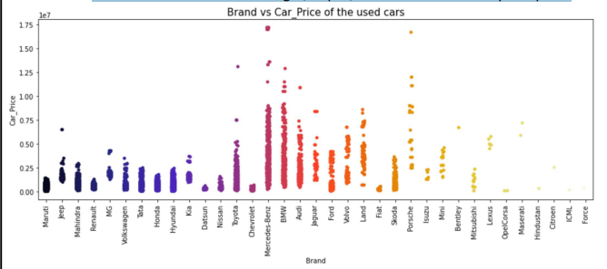**Observations:**

Car_Price vs Brand: The above strip plot shows how the used car prices changes depending on Brands. Here the cars from Mercedes_Benz and BMW brand have high price compared to other brands.

### 

**Observations:**

* **Car_Price vs Fuel_type:** From the graph we can conclude that more number of cars are using Petrol and Diesel fuels and these cars have wide range of price from minimum to maximum. And very few of the cars uses CNG, LPG, and Electricity as fuel type which are not much expensive when compared to that of the diesel and petrol cars.

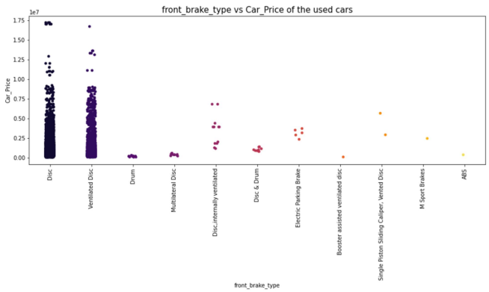

* **Observations:**

**Car_Price vs front_brake_type:** Looking at the above bar plot for front_brake_type vs Car_Price we can say that the cars with Disc and Ventilated Disc system for front wheels are having higher prices than other type of braking systems.

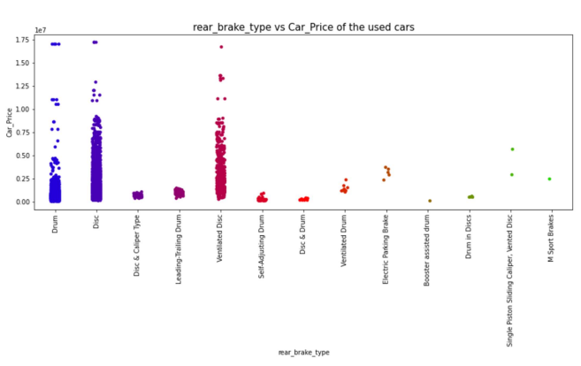

**Observations:**

**Car_Price vs rear_brake_type:** The above graph is representing a bar plot for rear_brake_type vs Car_Price which tells us that the cars having Ventilated Disc or Disc or Drum brake system are having higher prices than the cars with other type of braking system at rear side.

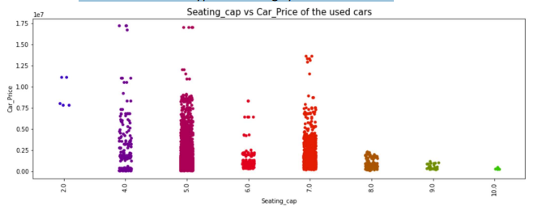

**Observations:**

Car_Price vs Seating_cap: Most of the cars have seating capacity of 5, 7 and 4 and these cars having higher prices than other cars. And only few cars are observed with the seating capacity of 10.

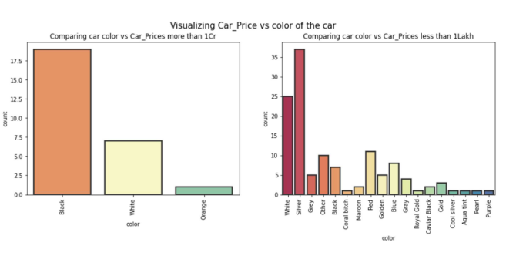

**Observations:**

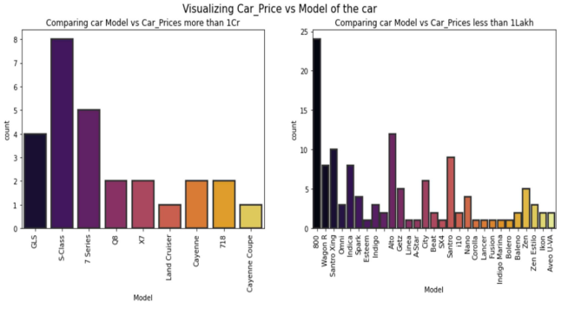Car_Price vs color: The first count plot is for the car color vs Car_Prices more than 1 Cr. The plot shows the colors of expensive cars. The Black color cars are more expensive compared to the cars with other colors. ¬ The second graph is for the car color vs car prices below 1 Lakh and it shows the colors of cars which are cheap. From the plot we can say the cars with silver color and white color have less price.

**Observations:**

Car_Price vs Model: The first plot is for car model vs car price more than 1Cr. This plot showing the models of expensive cars. The S-Class model are expensive compared to other models. ¬ The second plot is for car model vs car price less than 1 Lakh. This plot showing the models which are very cheap. So, from the graph we can say that the car model 800 have very less price.

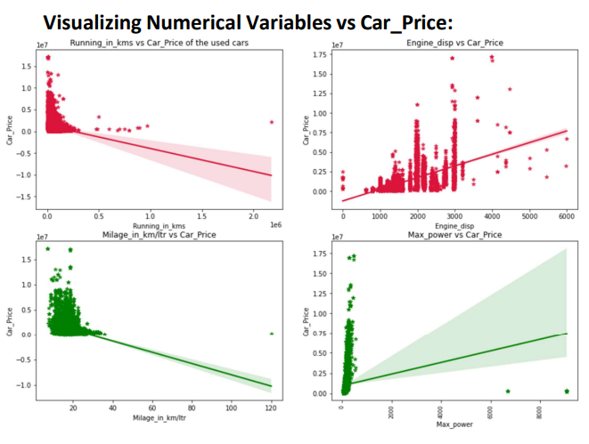

**Observations:**

Car_Price vs Running_in_kms: From the plot we can say that the prices of cars are higher for the cars which have less running in kms. We can also notice there is negative linear relation between the price and running of cars.

Car_Price vs Engine_disp: There is a positive correlation between car price and engine displacement. So, we can say as the engine disp or engine cc increases, the price of car also increases.

Car_Price vs Milage_in_km/ltr: The cars having the milage in the range of 10 to 20 km/ltr are having high sale price. From the graph we can also notice there is negative linear/correlation between the price and milage.

Car_Price vs Max_power: Looking at the graph we can say there is positive correlation between car price and maximum engine power so, we can say as maximum power engine increases, the car prices also go on increasing.

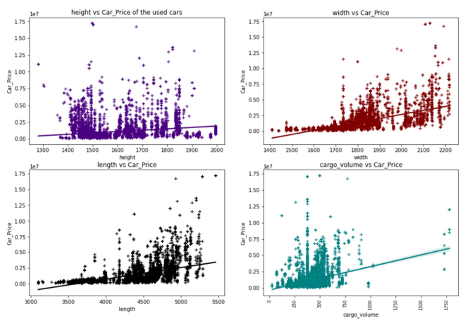

**Observations:**

Car_Price vs height: From the graph it is clear that the car price is not strongly related with the height of the car, we can say the cars having height in the range of 1400 mm to 1850 mm have somewhat high price.

Car_Price vs width: The graph shows there is some positive linear relation between car price and width of the car, so the cars having width in the range of 1750mm to 2200mm have high price. So we can conclude as the width of the car increases, the price of the car also goes on increasing.

Car_Price vs length: There is some positive linear relation between car price and length of the cars. As the length of the cars increases, the price of the cars also increases. The cars that are having the length above 4250mm have high price.

Car_Price vs Cargo_volume: There is some positive linear relation between price of the car and cargo_volume.

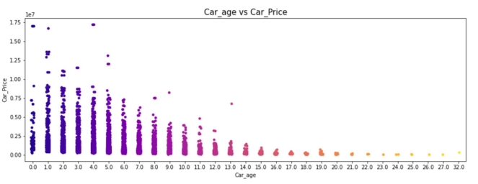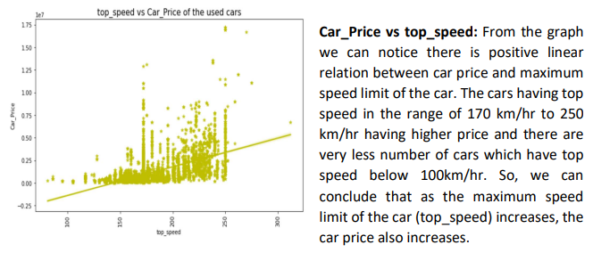

**Observations:**

Car_Price vs Car_age: From the above strip plot we can say that the older cars are having very lower prices when compared to the new cars that is the cars having very less age. So, there is negative relation between car price and age of the cars and we can conclude as the age decreases, the car prices increase.

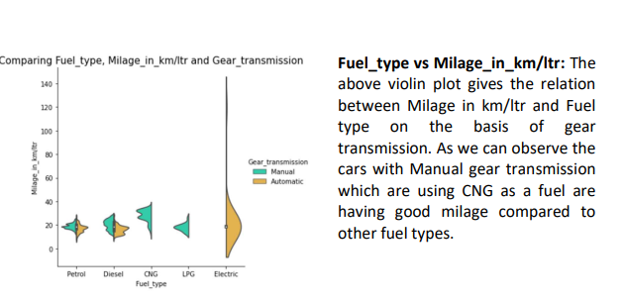

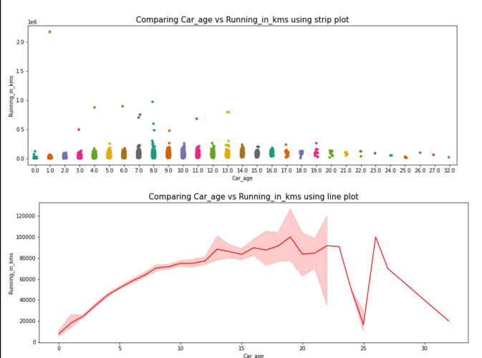

Car_age vs Running_in_kms: The above two graphs represent car_age vs Running in kms. The cars which have their age from 10 years to 20 years are highly used. That is the running kms for these cars are around 1 lakh kms.

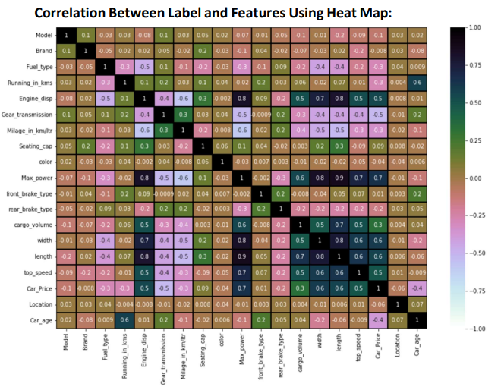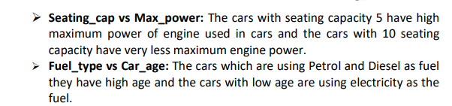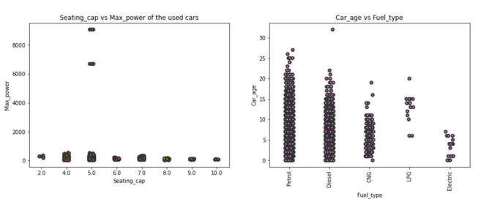

* 1. **Interpretation of the Results**

**Visualizations:** In univariate analysis I have used count plots and pie plots to visualize the counts in categorical variables and distribution plot to visualize the numerical variables. In bivariate analysis I have used bar plots, strip plots, line plots, reg plots, box plots, and boxen plots to check the relation between label and the features. Used pair plot to check the pairwise relation between the features. The heat map and bar plot helped me to understand the correlation between dependent and independent features. Detected outliers and skewness with the help of box plots and distribution plots respectively. And I found some of the features skewed to right as well as to left. I got to know the count of each column using bar plots.

**Pre-processing:** The dataset should be cleaned and scaled to build the ML models to get good predictions. I have performed few processing steps which I have already mentioned in the pre-processing steps where all the important features are present in the dataset and ready for model building.

**Model building:** After cleaning and processing data, I performed train test split to build the model. I have built multiple regression models to get the accurate R2 score, and evaluation metrics like MAE, MSE and RMSE. I got Extreme Gradient Boosting Regressor (XGB) as the best model which gives 97.526% R2 score. I checked the cross-validation score ensuring there will be no overfitting and underfitting. After tuning the best model, the R2 score of Extreme Gradient Boosting Regressor has been increased to 97.551% R2 score and Cross Validation Score as 94.9265 %. Finally, I saved my final model and got the good predictions results for price of used cars.

**4.CONCLUSION**

* 1. **Key Findings and Conclusions of the Study**

The case study aims to give an idea of applying Machine Learning algorithms to predict the sale price of the used cars. After the completion of this project, we got an insight of how to collect data, pre-processing the data, analyzing the data, cleaning the data and building a model. In this study, we have used multiple machine learning models to predict the sale price of the used cars. We have gone through the data analysis by performing feature engineering, finding the relation between features and label through visualizations. And got the important feature and we used these features to predict the car price by building ML models. After training the model we checked CV score to overcome with the overfitting issue. Performed hyper parameter tuning on the best model and the best model’s R2 score increased and was giving R2 score as 97.551%. We have also got good prediction results of car price.

**Findings:**

From the whole study we got to know that the continuous numerical variables having some strong positive linear relation with the label "Car_Price". By comparing car price and categorical variables we got to know that the cars having automatic gear transmission, cars from the city Delhi_NCR, cars using petrol and diesel as fuels, cars having the brands Benz and BMW and cars with 5-7 seating capacity have high sale price. While comparing continuous numerical variables and Car_Price we found that cars which are having good milage, engine displacement, less running in kms have good linear relation with the price that is the cars with this kind of qualities have high selling prices. We found outliers and removed them and further removed skewness. Looking at the heat map, I could see there were some features which were correlated with each other, so I used VIF method to remove the feature causing multicollinearity and scaled the data to overcome the data biasness.

**4.2 Learning Outcomes of the Study in respect of Data Science**

While working on this project I learned many things about the features of cars and about the car selling web platforms and got the idea that how the machine learning models have helped to predict the price of used cars which provides greater understanding into the many causes and benefits of selling old cars. I found that the project was quite interesting as the dataset contains several types of data. I used several types of plotting to visualize the relation between target and features. This graphical representation helped me to understand which features are important and how these features describe selling price of the old cars. Data cleaning was one of the important and crucial things in this project where I dealt with features having string values, features extraction and selection. Finally got XGB Regressor as best model. The challenges I faced while working on this project was when I was scrapping the real time data from “cardekho” website, it took so much time to gather data. The data was quite difficult to handle and cleaning part was challenging too but I was able to clean the data successfully but was unable to remove skewness in Seating_cap column so moved forward keeping it as it is. Finally, our aim was achieved by predicting the sale price of used cars and built car price evaluation model that could help the clients to understand the future price of used cars.

**4.3 Limitations of this work and scope for future work**

**Limitations**: The main limitation of this study is the low number of records that have been used. In the dataset our data is not properly distributed in some of the columns many of the values in the columns are “-“ and null values and some values which are not realistic. So, because of that data our models may not make the right patterns and the performance of the model also reduces. So that issues need of missing data would need to be taken care of.

**Future work:** As future work, we intend to collect more data and to use more advanced techniques like artificial neural networks to predict car prices. In future this machine learning model may bind with various website which can provide real time data for price prediction. Also, we may add large historical data of car price which can help to improve accuracy of the machine learning model.